**HOSPITAL NETWORK**

Submitted in partial fulfillment of the requirements for the award of degree of

**BACHELOR OF ENGINEERING**

**IN**

**COMPUTER SCIENCE & ENGINEERING**



**Submitted to:**

**Er. Inderjeet Singh**

**Submitted By:**

**NAME: Simranjeet Singh**

**Roll No:17BCS1708**

**DEPARTMENT OF COMPUTER SCIENCE & ENGINEERING**

**Chandigarh University, Gharuan**

**May 2019**

**ACKNOWLEDGEMENT**

I have taken efforts in this project. However, it would not have been possible without the kind support and help of many individuals and organizations. I would like to extend my sincere thanks to all of them.I am highly indebted toEr. Inderjeet Singh for their guidance and constant supervision as well as for providing necessary information regarding the project & also for their support in completing the project.

I would like to express my gratitude towards my parents & my mentors for their kind co-operation and encouragement which help me in completion of this project.

My thanks and appreciations also go to my team mates and friends in developing the project and people who have willingly helped me out with their abilities.

**Simranjeet singh.**

**ABSTRACT**

In this modern era everything is interconnected for a seamlessly fast progression, each and every large organization having large infrastructure requires to communicate securely and swiftly. Universities, Big Offices, Hospitals require a good infrastructure to communicate which can only be achieved by computer Networking. Computer communication network is growing at a rapid pace, Computer communication networks are based on a technology that provides the technical infrastructure, where routing protocols are used to transmit packets across the Internet. Routing protocols specify how routers communicate with each other by transmitting information. The router has prior knowledge about the neighboring networks, which can help in selecting the routes between two nodes. There are various types of routing protocols being widely used. There are two different ways to configure routing tables in the router. They are static routing and dynamic routing. In this paper, we have analyzed and simulated a proposed wired Local Area Network using Static routing protocols. Therefore configuration of the network is done using static routing in CISCO packet tracer simulator.

**List of Figures**

|  |  |  |
| --- | --- | --- |
| **Figure No.** | **Title** | **Page No.** |
| 1. | Map of Hospital | 7 |
| 2. | DFD of packet sent form one pc to another | 9 |
| .. | ……. | . |
| .. | ……. | . |

**Table of Contents**

|  |  |  |
| --- | --- | --- |
| **Sr. No.** | **Topic** | **Page No.** |
|  |  |  |
| 1 | Introduction |  |
|  |  |  |
| 2 | Software Requirement Specifications |  |
|  |  |  |
| 3 |  |  |
|  | Designing |  |
| 4 |  |  |
|  | METHODOLOGY |  |
| 5 | Snapshots of network and test result |  |
|  |  |  |
| 6 | Conclusion |  |
|  |  |  |

**Chapter 1**

**Introduction**

The main objective is to interconnect every single block and every single room of each block so that every computer in the hospital can communicate with any other computer in the hospital. There are few blocks in hospital premises located at a few distances from each other and every block has 20-25 computers and a few servers. This objective can be fulfilled by connecting every computer using any routing protocol. Static routing is used in this network. Static routing is easy to implement in small scale networks. They are very secure and predictable as the route to the destination is always remains the same. It doesn't require any routing algorithm or update mechanisms. Hence no extra resources such as CPU and memory is required. Static routing is simply the process of manually entering routes into the routing table of a device using its a configuration file that is loaded when the routing device starts up. In static routing, all the changes in the logical network layout need to be manually done by the system administrator. All these actions are performed in the Cisco packet tracer. Packet tracer is a visual simulation tool designed by Cisco systems that allow the user to create network topologies and imitate modern computer networks. The software allows users to simulate the configuration of Cisco routers and switches using a simulated command-line interface. Packet Tracer makes use of a drag and drop user interface, allowing users to add and remove simulated network devices.

Software Used

1. Cisco packet tracer

**Chapter 2**

**Software Requirement Specifications (SRS)**

Network should be created keeping all the blocks and number of computers that are required to be connected.

The design includes of 5 main blocks which are names as Emergency block, OPD block, Eye block, Dental block, and Education block. This design consists of 5 Routers, 9 Switches, 3 servers, and 170-200 computers.

There should be-

* Emergency block with 1 router, 2 switches, and 48 computers.
* Dental block with 1 router, 1 switches, and 18 computers.
* OPD block with 1 router, 1 switch and 24 computer
* Eye block with 1 router, 1 switch, and 48 computers.
* Education block with 1 router,3 servers, 3 switches, and 53 computers.

Design of Hospital premises

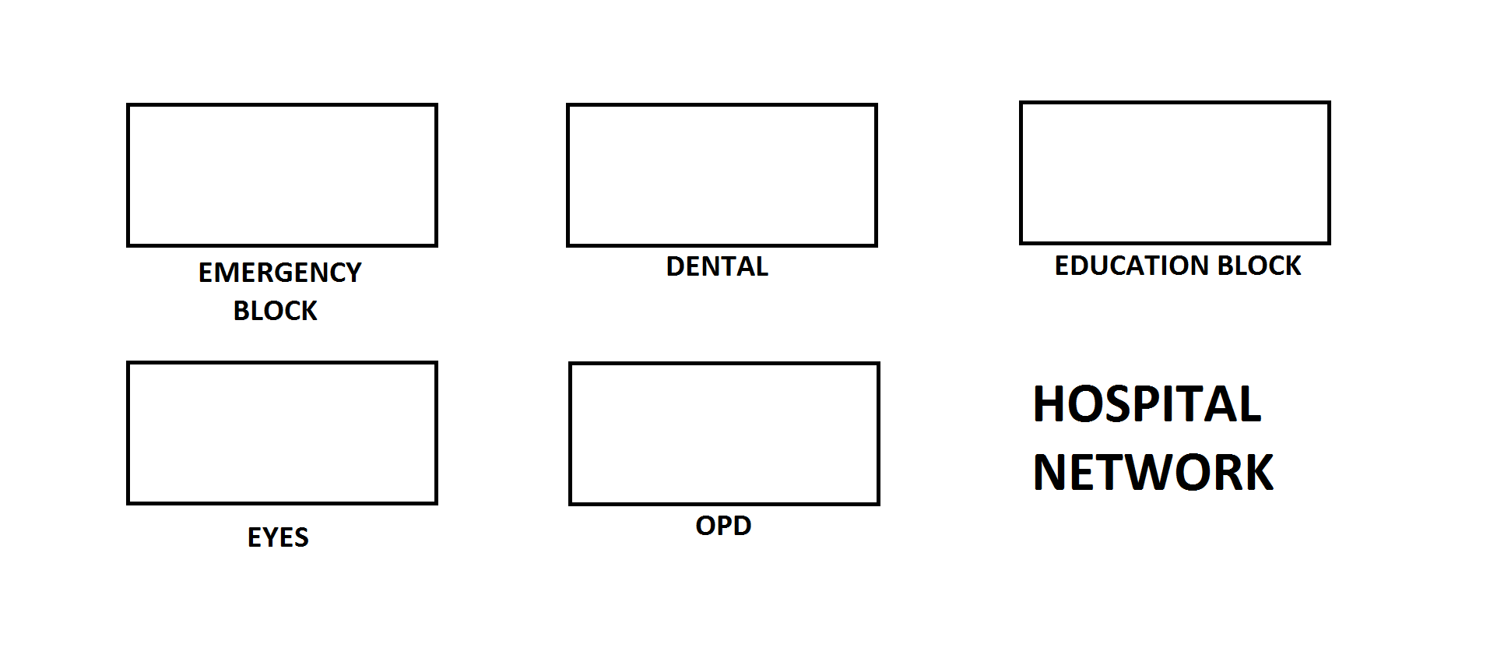

There are 5 blocks in hospital premises.

* Emergency block
* Dental block
* Education block
* Eyes block
* OPD block

**DEVICES AND EQUIPTMENTS REQUIRED**

* NIC (Network Interface Card)
* Repeater
* Modem
* Bridge
* Hub
* Switch
* Router
* Computer
* **Routers**– A router is a device like a switch that routes data packets based on their IP addresses. Router is mainly a Network Layer device. Routers normally connect LANs and WANs together and have a dynamically updating routing table based on which they make decisions on routing the data packets. Router divide broadcast domains of hosts connected through it.
* **Modem**  is a hardware device that converts data into a format suitable for a transmission medium so that it can be transmitted from computer to computer,modem modulates one or more carrier wave signals to encode digital information for transmission and demodulates signals to decode the transmitted information. The goal is to produce a signal that can be transmitted easily and decoded reliably to reproduce the original digital data.
* **Switch** – A switch is a multiport bridge with a buffer and a design that can boost its efficiency(a large number of ports imply less traffic) and performance. A switch is a data link layer device. The switch can perform error checking before forwarding data, that makes it very efficient as it does not forward packets that have errors and forward good packets selectively to correct port only.  In other words, switch divides collision domain of hosts, but broadcast domain remains same.
* **Repeater** – A repeater operates at the physical layer. Its job is to regenerate the signal over the same network before the signal becomes too weak or corrupted so as to extend the length to which the signal can be transmitted over the same network. An important point to be noted about repeaters is that they do not amplify the signal. When the signal becomes weak, they copy the signal bit by bit and regenerate it at the original strength. It is a 2 port device.
* **Bridge** – A bridge operates at data link layer. A bridge is a repeater, with add on the functionality of filtering content by reading the MAC addresses of source and destination. It is also used for interconnecting two LANs working on the same protocol. It has a single input and single output port, thus making it a 2 port device.
* **Hub** – A hub is basically a multiport repeater. A hub connects multiple wires coming from different branches, for example, the connector in star topology which connects different stations. Hubs cannot filter data, so data packets are sent to all connected devices.  In other words, collision domain of all hosts connected through Hub remains one.  Also, they do not have intelligence to find out best path for data packets which leads to inefficiencies and wastage.
* **Computers**- A computer is a machine that can be instructed to carry out sequences of arithmetic or logical operations automatically via computer programming. Modern computers have the ability to follow generalized sets of operations, called programs. These programs enable computers to perform an extremely wide range of tasks.

**Chapter 3**

**Designing**

Date flow diagram



Hospital design



**Chapter 4**

**METHODOLOGY**

**Project Goal**

The main objective is to interconnect every single block and every single room of each block so that every computer in the hospital can communicate with any other computer in the hospital. There are few blocks in hospital premises located at a few distances from each other and every block has 20-25 computers and a few servers. This objective can be fulfilled by connecting every computer using any routing protocol.

Static routing is used in this network. Static routing is easy to implement in small scale networks. They are very secure and predictable as the route to the destination is always remains the same. It doesn't require any routing algorithm or update mechanisms. Hence no extra resources such as CPU and memory is required. Static routing is simply the process of manually entering routes into the routing table of a device using its a configuration file that is loaded when the routing device starts up. In static routing, all the changes in the logical network layout need to be manually done by the system administrator.

**USES OF STATIC ROUTING**

* Static routing can be used to define an exit point from a router when no other routes are available or necessary. This is called a default route.
* Static routing can be used for small networks that require only one or two routes. This is often more efficient since a link is not being wasted by exchanging dynamic routing information.
* Static routing is often used as a complement to dynamic routing to provide a failsafe backup in the event that a dynamic route is unavailable.
* Static routing is often used to help transfer routing information from one routing protocol to another (routing redistribution).

**ADVANTAGES**

* Static routing causes very little load on the CPU of the router, and produce no traffic to other routers.
* Static routing leaves the network administrator with full control over the routing behavior of the network.
* Static Routing Is very easy to configure on small networks.

All these actions are performed in the Cisco packet tracer. Packet tracer is a visual simulation tool designed by Cisco systems that allow the user to create network topologies and imitate modern computer networks. The software allows users to simulate the configuration of Cisco routers and switches using a simulated command-line interface. Packet Tracer makes use of a drag and drop user interface, allowing users to add and remove simulated network devices.

**Now we will discuss how we implemented these steps into our project:**

Network design is created keeping all the blocks and number of computers that are required to be connected. The design includes of 5 main blocks which are names as Emergency block, OPD block, Eye block, Dental block, and Education block. This design consists of 5 Routers, 9 Switches, 3 servers, and 170-200 computers.

. Number of Devices used

* Emergency block has 1 router, 2 switches, and 48 computers.
* Dental block has 1 router, 1 switches, and 18 computers.
* OPD block has 1 router, 1 switch and 24 computer
* Eye block has 1 router, 1 switch, and 48 computers.
* Education block has 1 router,3 servers, 3 switches, and 53 computers.

First of all the routers and switches are placed according to the proposed design and computers are connected to them systematically. There are various techniques for making a connection. Topologies like bus topology, star topology, ring topology. Computers are connected to the switches in star topology

The second step is providing IP Addresses to computers and servers. An Internet Protocol address is a numerical label assigned to each device connected to a computer network that uses internet protocol for communication.An IP address serves two main functions that are host or network interface identification and location addressing. All the computers connected in the design are given separate IP addresses. Routers are also assigned with different IP addresses which act as a gateway IP address. Switches are connected with routers with point to point topology. All the routers are connected to each other in a bus topology.

Static routing is performed on all the routers to interconnect them. Static routing is easy to implement in small scale networks. They are very secure and predictable as the route to the destination is always remains the same. Static routing is simply the process of manually entering routes into the routing table of a device using its a configuration file that is loaded when the routing device starts up. In static routing, all the modification in the logical network layout need to be manually done by the system administrator

After all the technical part is over, time to test the created network. Testing can be done by sending a packet from one computer to the neighboring computers if this is successful then send a packet to another computer connected to another computer in the network. The result of the packet sent is shown in Cisco packet tracer.

**Chapter 5**

**Snapshots of network and test result**

There is a working model of a hospital network in which 170-200 computers are interconnected with each other. All the computer have static IP addresses which can communicate with each other within the network.

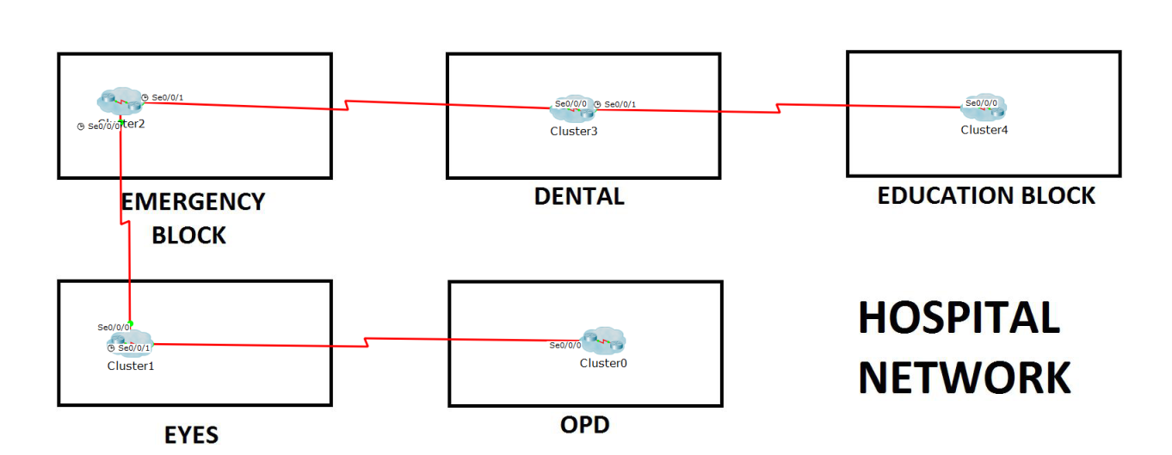

This network has 5 blocks in which there are router,switches, servers and computers are connected and every network has been clustered.

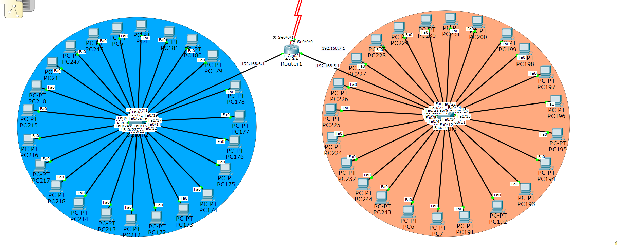

The above network represent emergency block in which there is one router, two switches and 48 computers.

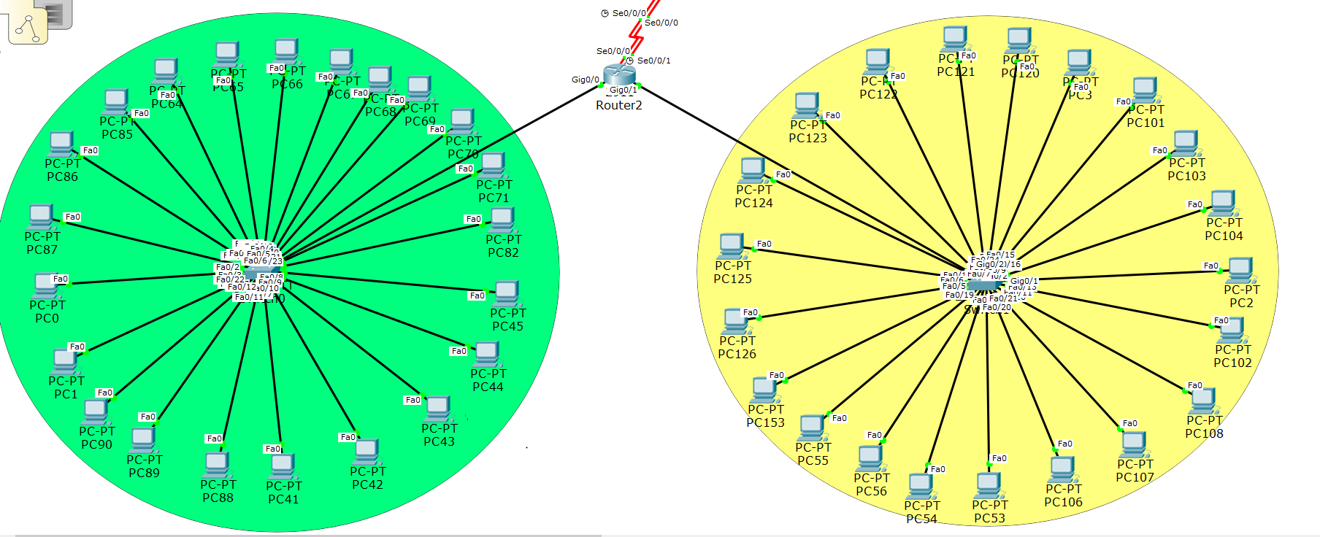

This is the network structure of eye block in which there is one router, two switches and 48 computers.

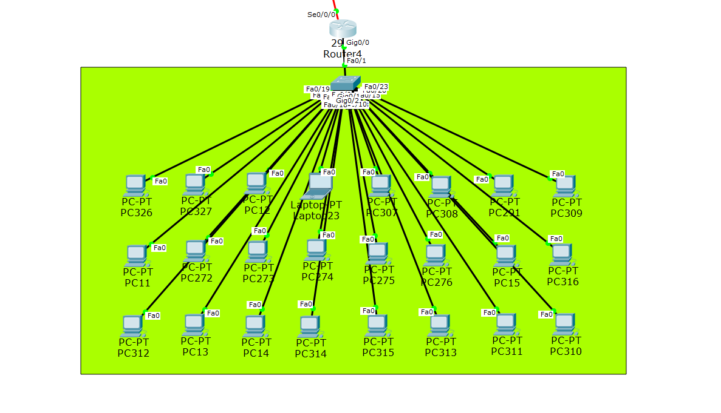

OPD block has 1 router, 1 switch and 24 computers.

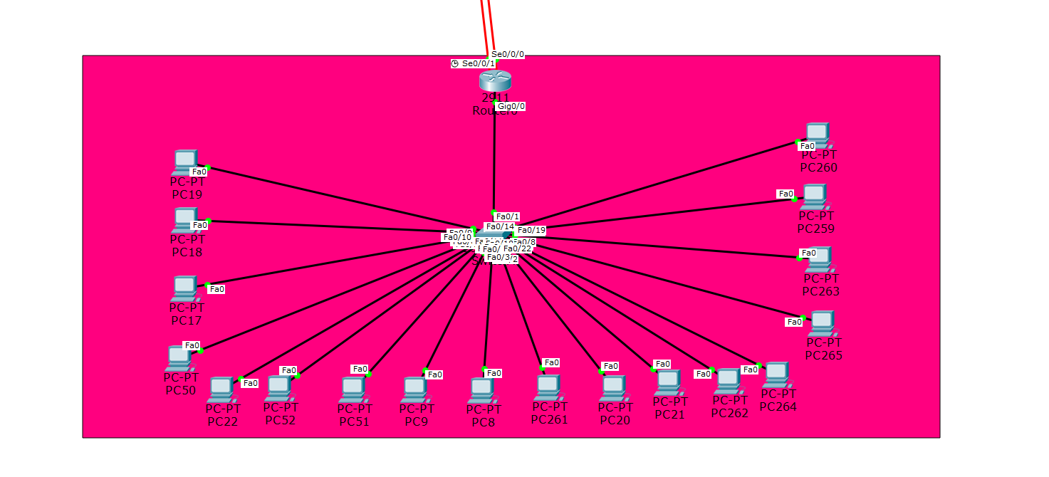

The above network represent emergency block in which there is one router, two switches and 48 computers.

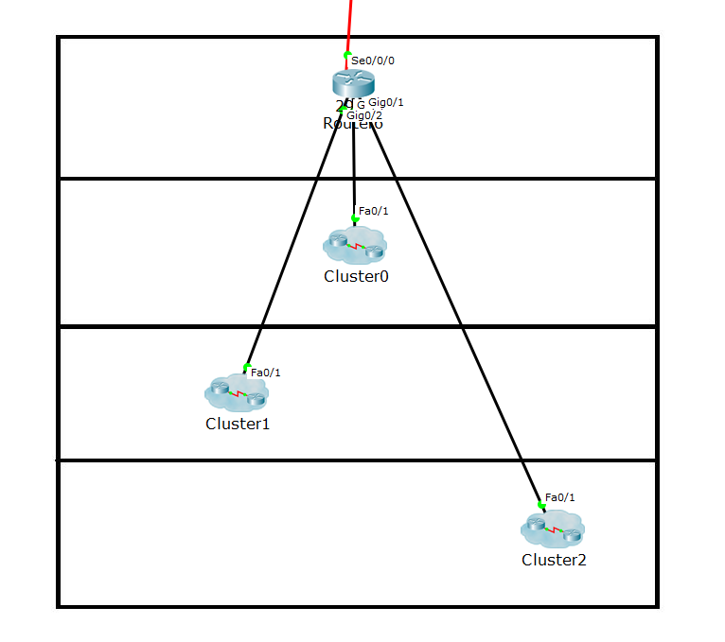

The above is network of education block. It has 3 switches and many computers connected to them

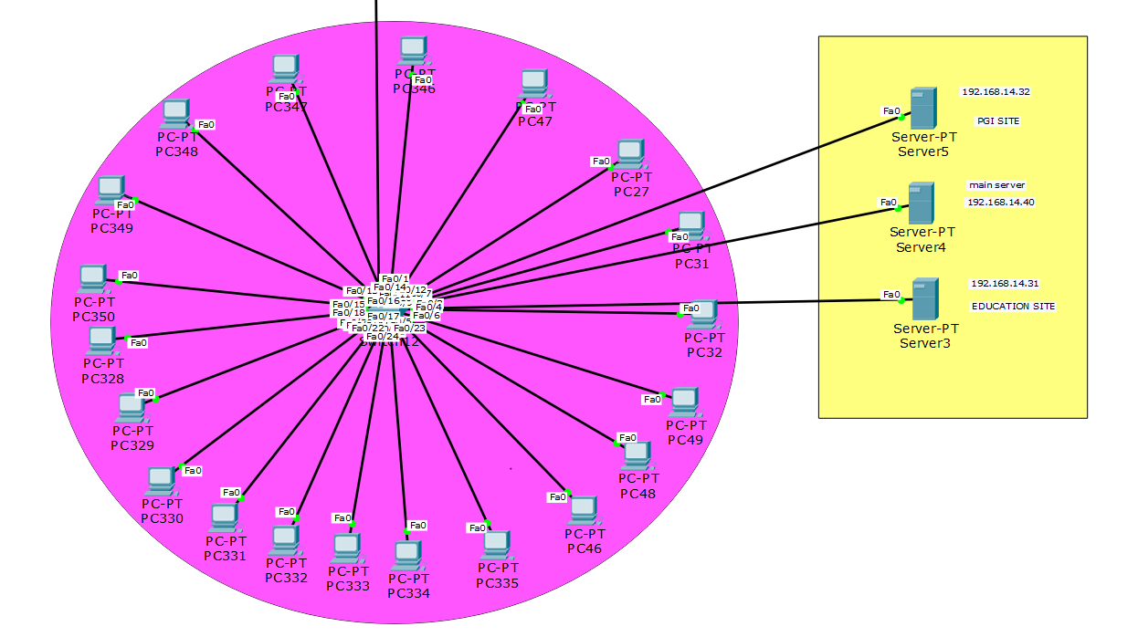

This is the internal structure of first switch inside education block cluster. This network has 1 switch, 3 servers and 20 computers

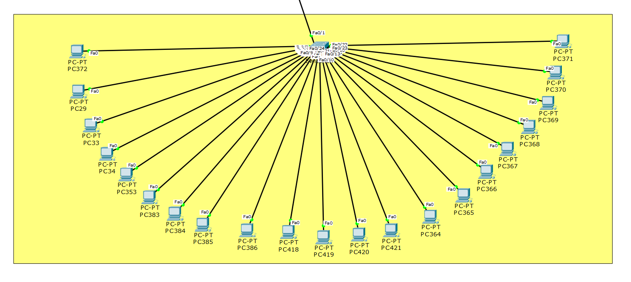

This is second sub network of educational block, Switch in this network is connected to the main router of education block.

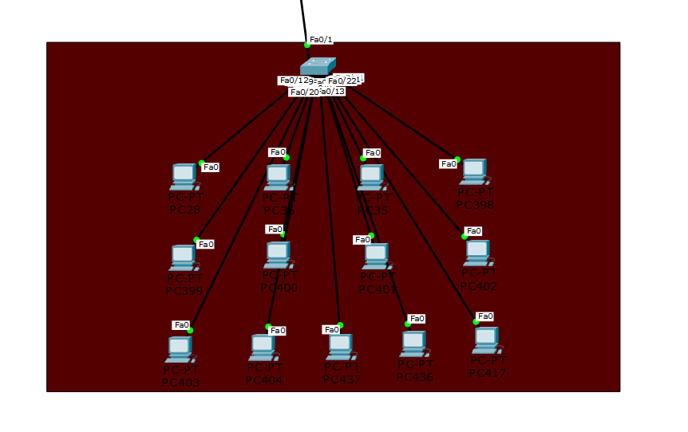

This is third sub network of educational block, Switch in this network is connected to the main router of education block. There are 13 computer connected in star topology to the switch.

There are 2 internet sites that are hosted on 2 different servers which can be accessed by any computer in the network. Both the sites are hosted on a different server and they both have different IP addresses but they can be accessed by names i.e. pgi.com and edu.com due to DNS service.



There are 2 internet sites that are hosted on 2 different servers which can be accessed by any computer in the network. Both the sites are hosted on a different server and they both have different IP addresses but they can be accessed by names i.e pgi.com and edu.com due to DNS service.

**IP configuration of computers, servers and router**

Click on any connected pc in the network and enter IP adsress, dns ip etc.

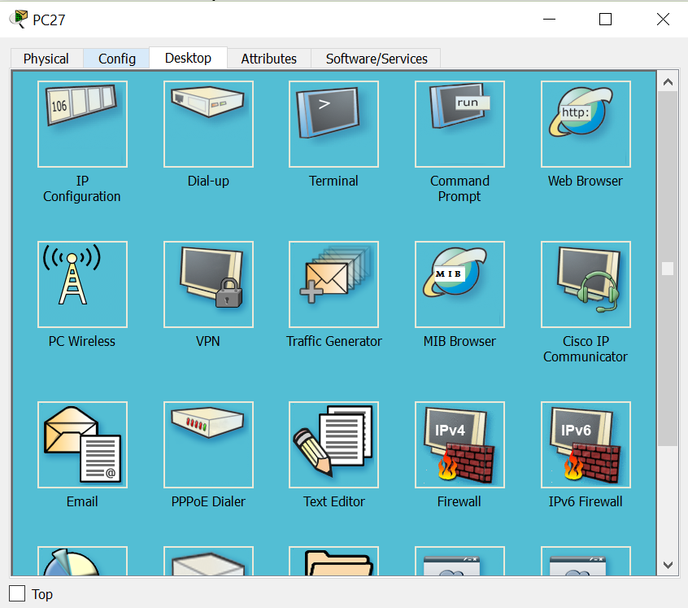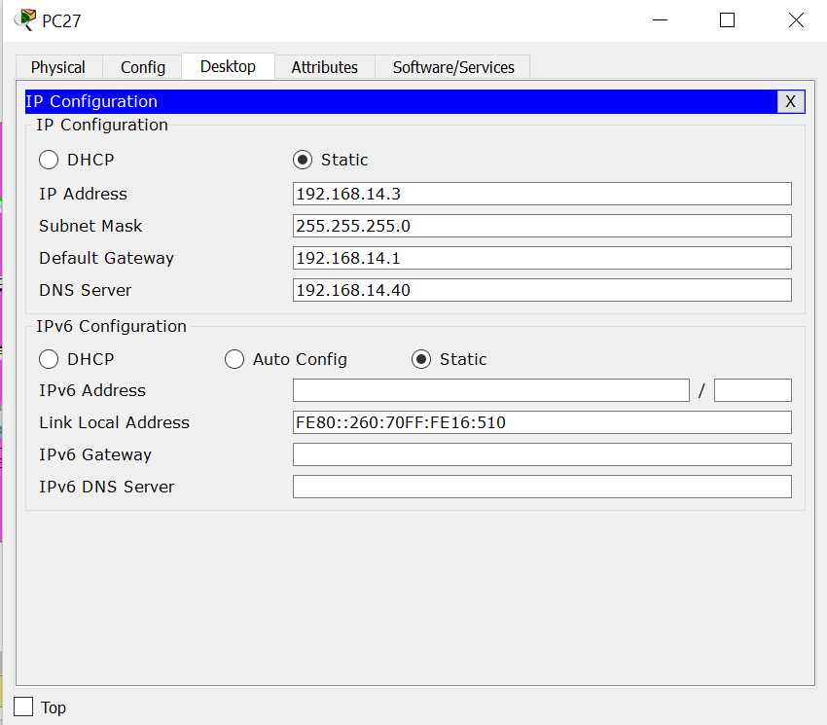

Router

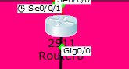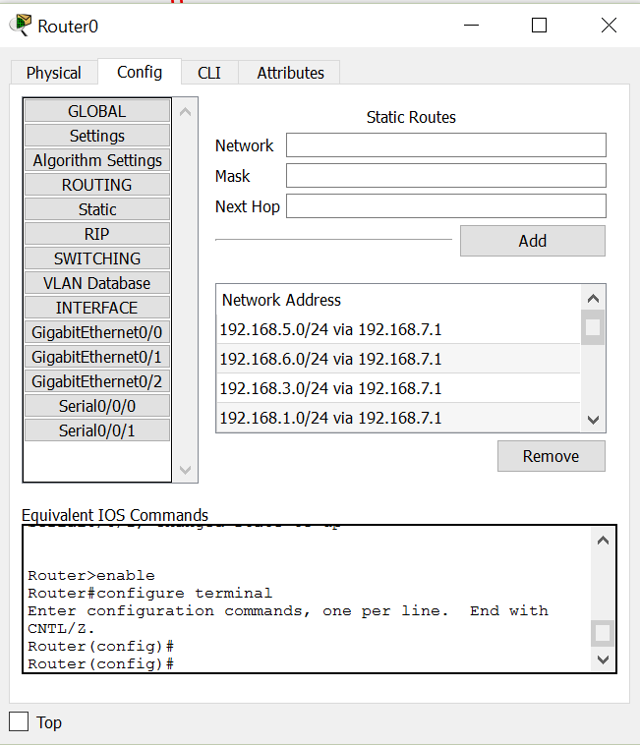

We need to set up two servers and configure them, click on one of the added server and go to services and add all site related documents. The click on desktop and click on IP configuration and configure it.

PGI Server

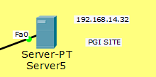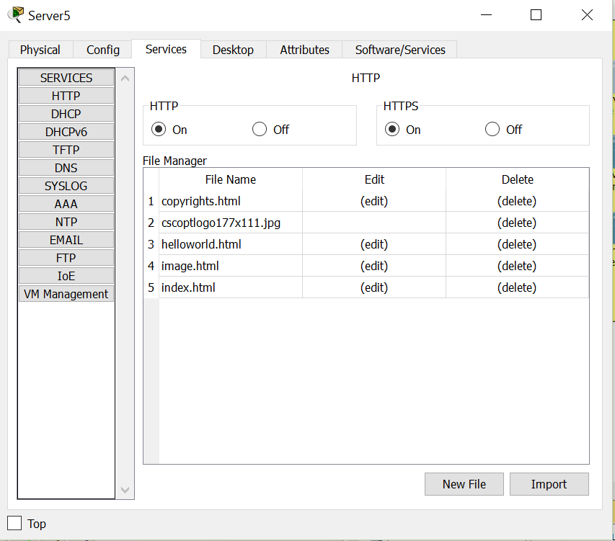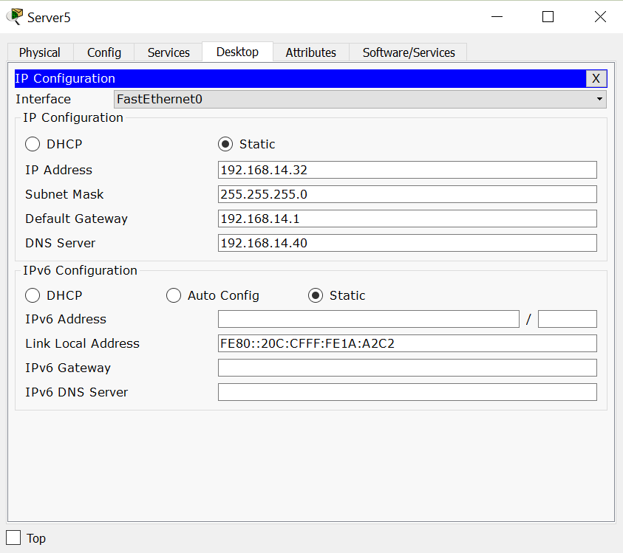

Education block Server

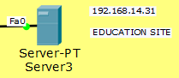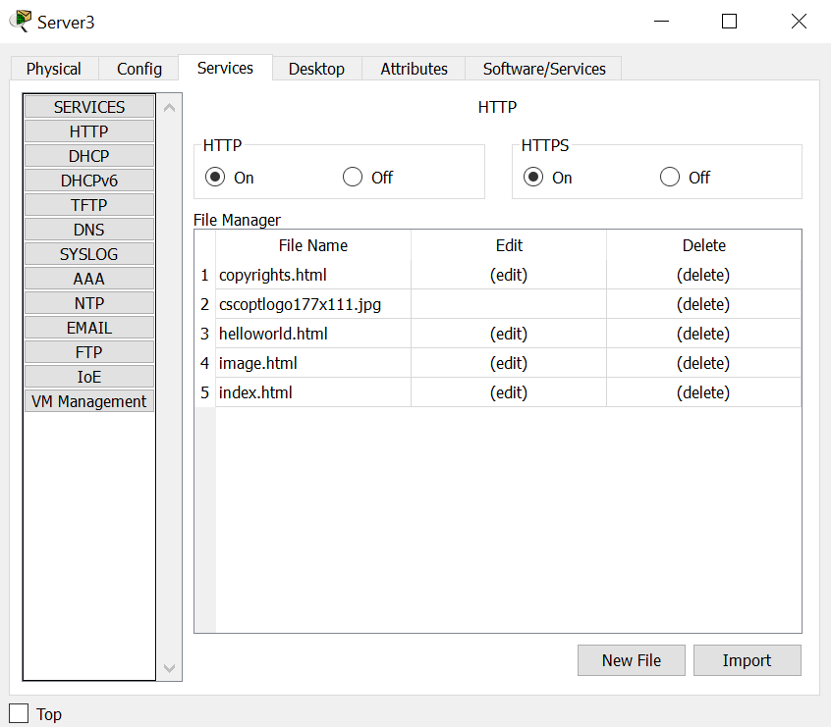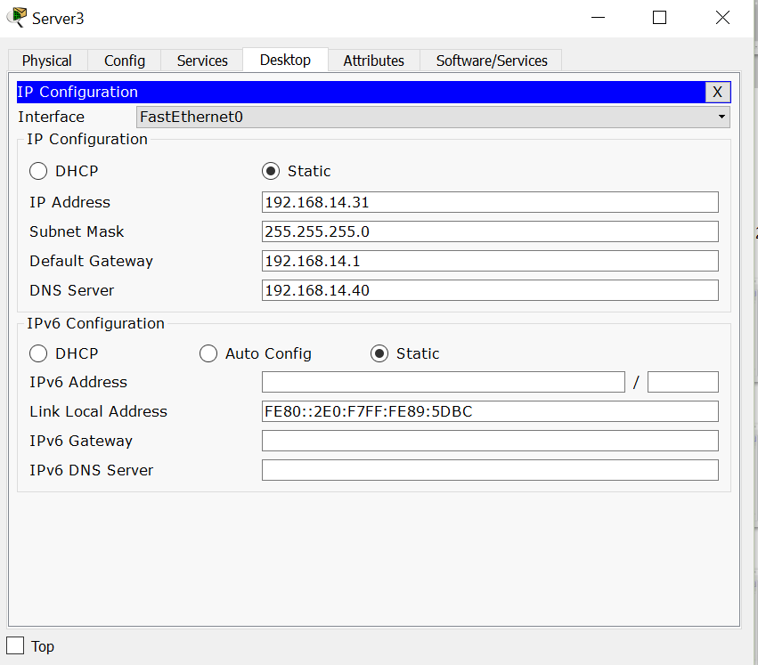

DNS Server

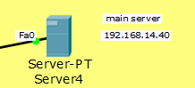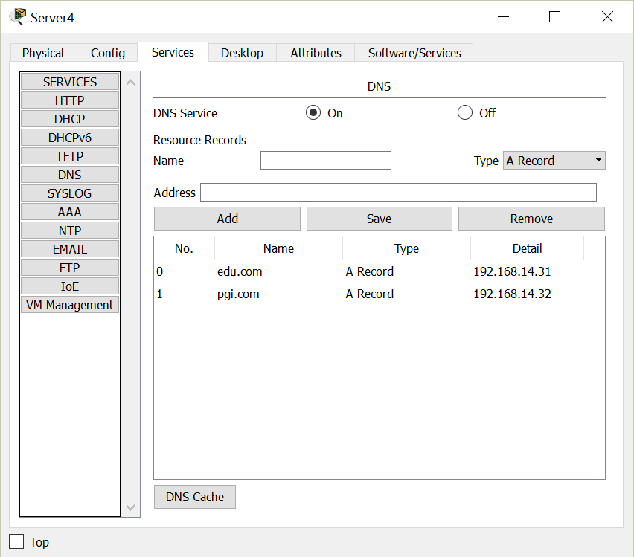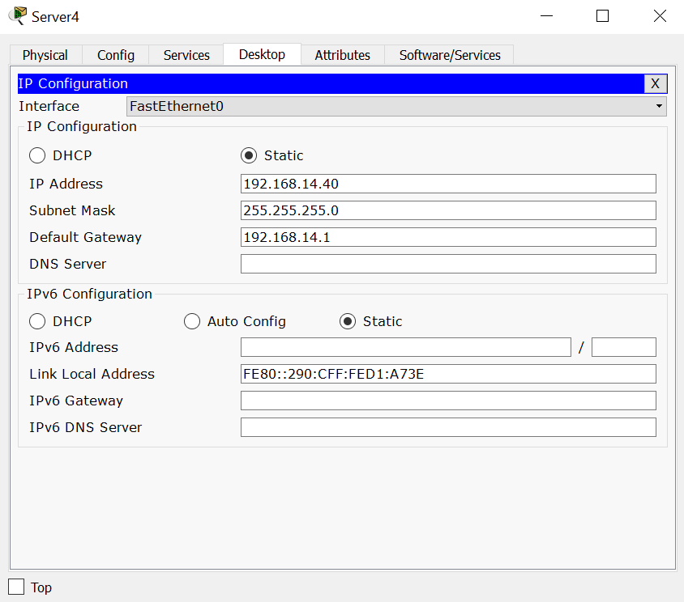

**TESTING**

To can test the created network by sending packet from one computer to another

TESTING- PC 17 TO PC 106

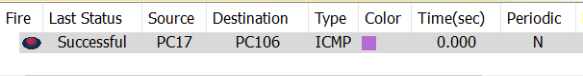

The packet is sent from PC17, the packet first reaches to the switch and then router. The router guides the packet towards the destination. The packet is recived by the local router of the target PC. The router then forwards to packet to the target PC and the packet is received by PC106 successfully.

To access to pgi site open web browser in any computer in the network, enter site name i.e. pgi.com and press enter . PGI site will open.

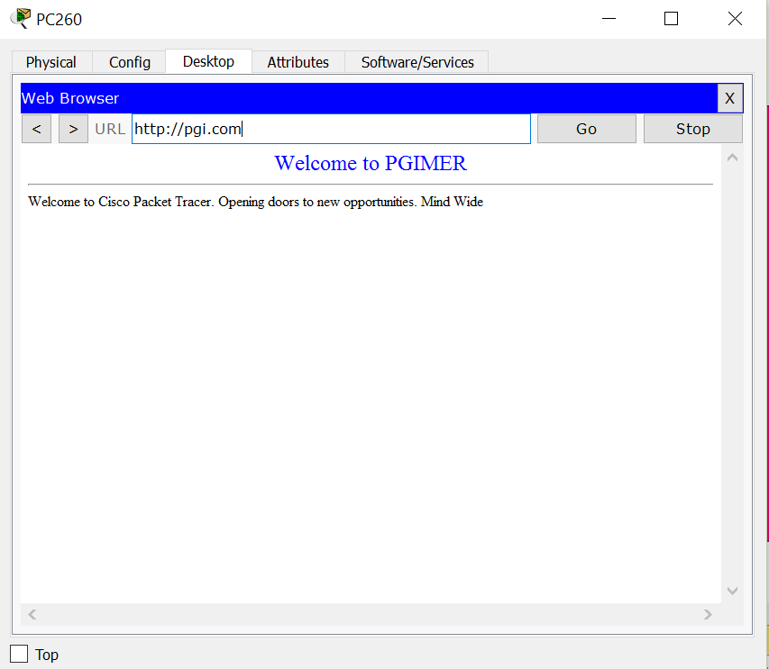

To access to education site open web browser in any computer in the network, enter site name i.e. pgi.com and press enter . PGI site will open.

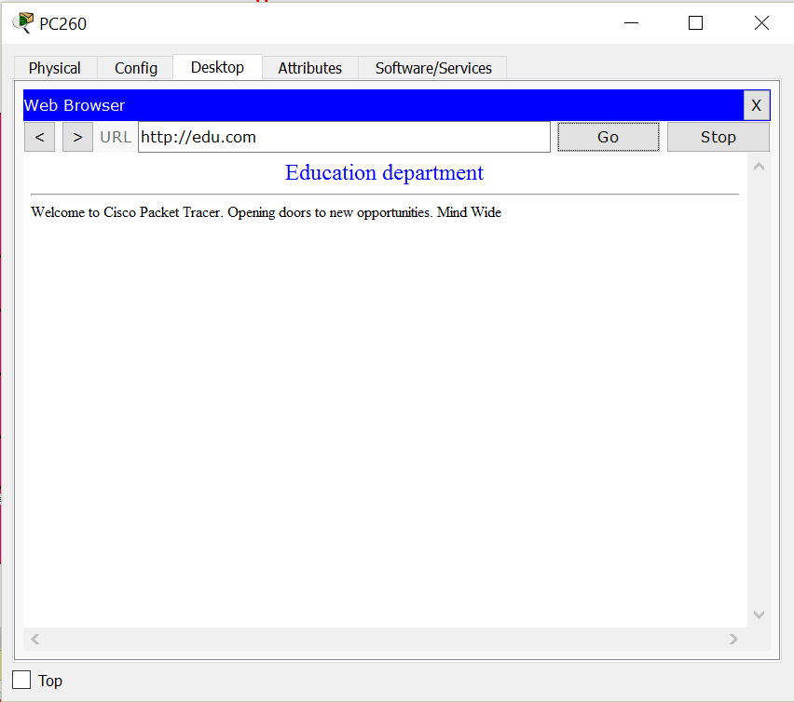

And we can also access these sites by typing ip addresses of site.

First site ip is 192.168.32

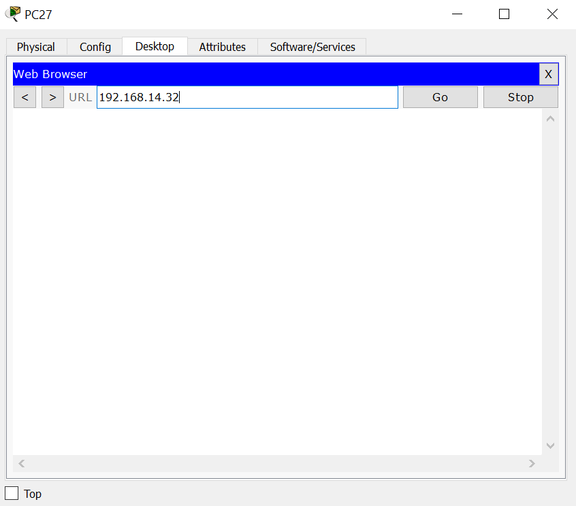

Press go and PGI site will open

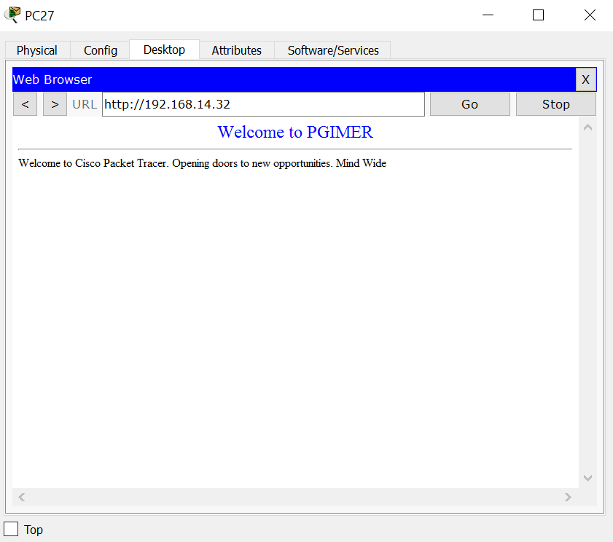

And second site ip is 192.168.31

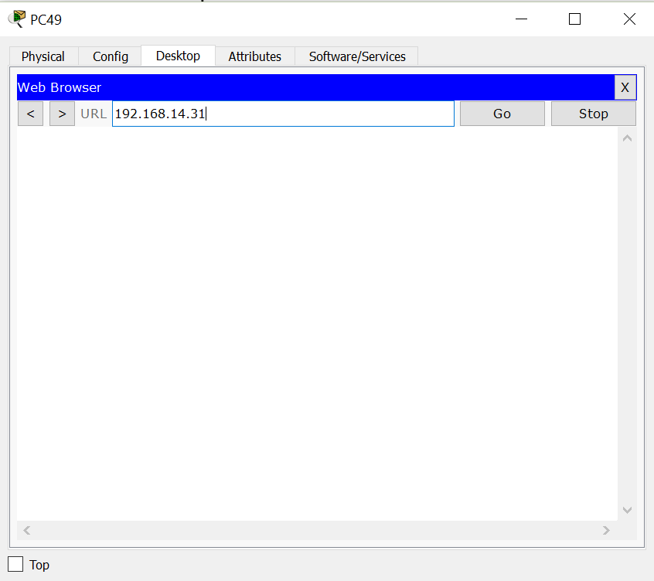

Press go.

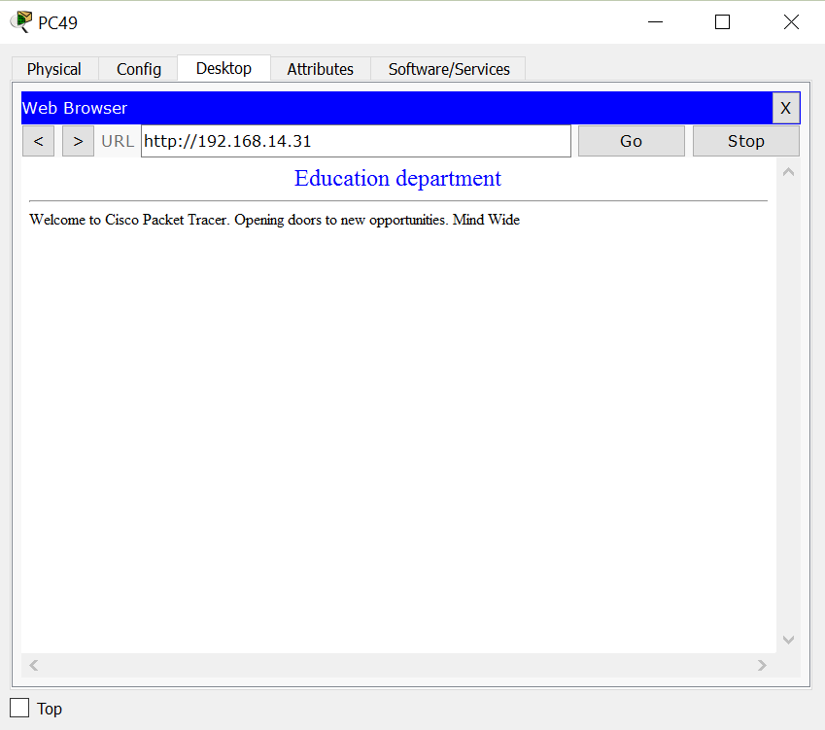

**Chapter 6**

**Conclusion**

There is a working model of a hospital network in which 170-200 computers are interconnected with each other. All the computer have static IP addresses which can communicate with each other within the network.

This network has 5 blocks in which there are router,switches, servers and computers are connected and every network has been clustered.

There are 2 internet sites that are hosted on 2 different servers which can be accessed by any computer in the network. Both the sites are hosted on a different server and they both have different IP addresses but they can be accessed by names i.e. pgi.com and edu.com due to DNS service.

There are 2 internet sites that are hosted on 2 different servers which can be accessed by any computer in the network. Both the sites are hosted on a different server and they both have different IP addresses but they can be accessed by names i.e pgi.com and edu.com due to DNS service.

To access to pgi site open web browser in any computer in the network, enter site name i.e. pgi.com and press enter . PGI site will open.